**Ayesha Eiman Bukhari**

**SP20-BCS-021**

**Assignment: 2**

import React from 'react';

import { Text, View, StyleSheet , TextInput ,Button , Image} from 'react-native';

import Constants from 'expo-constants';

import Ayeshabukhari.js from './components/Ayeshabukhari.js';

import { Card } from 'react-native-paper';

export default function App() {

return (

<View style={styles.container}>

<Image style={{height: 100, alignSelf: 'center', margin:20}}

source={require ('./assets/eman pic.PNG')} />

<TextInput style={styles.textinput} placeholder="Email Address"

underlineColorAndroid={'transparent'} />

<TextInput style={styles.textinput} placeholder="Password"

underlineColorAndroid={'transparent'} />

<Button style={styles.button}>

<Text style={styles.btntext}> Sign Up </Text>

</Button>

<Text style={styles.footer}>

Alreadyamember ? SignUp! </Text>

<Card>

<AssetExample />

</Card>

</View>

);

}

const styles = StyleSheet.create({

container: {

flex: 1,

justifyContent: 'center',

paddingTop: Constants.statusBarHeight,

backgroundColor: '#3498db',

padding: 8,

},

textinput: {

margin: 30,

alignSelf: 'stretch',

height: 30,

marginBottom: 10,

color: '#fff',

borderBottomColor: '#f8f8f8',

borderBottomWidth: 1,

},

footer: {

margin: 20,

fontSize: 15,

color: '#fff',

paddingBottom: 40,

marginBottom:10,

textAlign: 'center',

},

button: {

alignSelf: 'stretch',

alignItems: 'center',

textShadowColor: '#30db',

padding: 20,

background: '#3469db',

marginTop: 5,

}

});

**OUTPUT:**

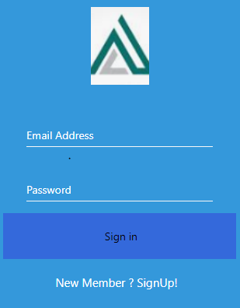

**Sample**

